

Multidisciplinary Project Report (Sequence Comparaison Report)

SnowFLOWS: Generative Spatio-Temporal Modelling of Snow Cover Dynamics Using Satellite Imagery

By:
Carla Youness (232771)
Nour el Saghir (230520)
Reina Taher (230134)
Ali Mansour (231039)
Hassan Dakhlallah (222814)

Supervisor(s):
Dr. Laurent Drapeau
Dr. Youssef El Bakouny

21/04/2026

École Supérieure d’Ingénieurs de Beyrouth
Université Saint-Joseph de Beyrouth

Introduction:
This document presents the tuning process of an LSTM-based time-series forecasting model for snow surface prediction using Sentinel-2 satellite data. The objective is to evaluate the impact of different sequence lengths on prediction performance and identify the most suitable configuration for accurate and reliable forecasting.
Multiple experiments were conducted using varying historical input window sizes, and performance was evaluated using MAE and RMSE. In addition, prediction quality was assessed visually in terms of temporal consistency, peak representation, and forecast realism.
To further investigate data limitations, an additional experiment was carried out using a 25-year MODIS dataset to determine whether performance constraints in Sentinel-2 models were due to limited temporal coverage or inherent data and model characteristics.

Model Configuration
The forecasting model is based on a stacked LSTM architecture designed for sequential time-series learning. It consists of two LSTM layers (96 and 64 units respectively) to capture short- and long-term temporal dependencies, followed by dropout layers (0.15) to reduce overfitting. The output is passed through two fully connected dense layers (32 and 16 neurons) before producing the final prediction.
The model is trained using the Adam optimizer with a learning rate of 0.0003. A custom peak-weighted Huber loss function is used to give higher importance to extreme snow events, improving physical realism in predictions. Performance is evaluated using MAE and a custom RMSE metric.
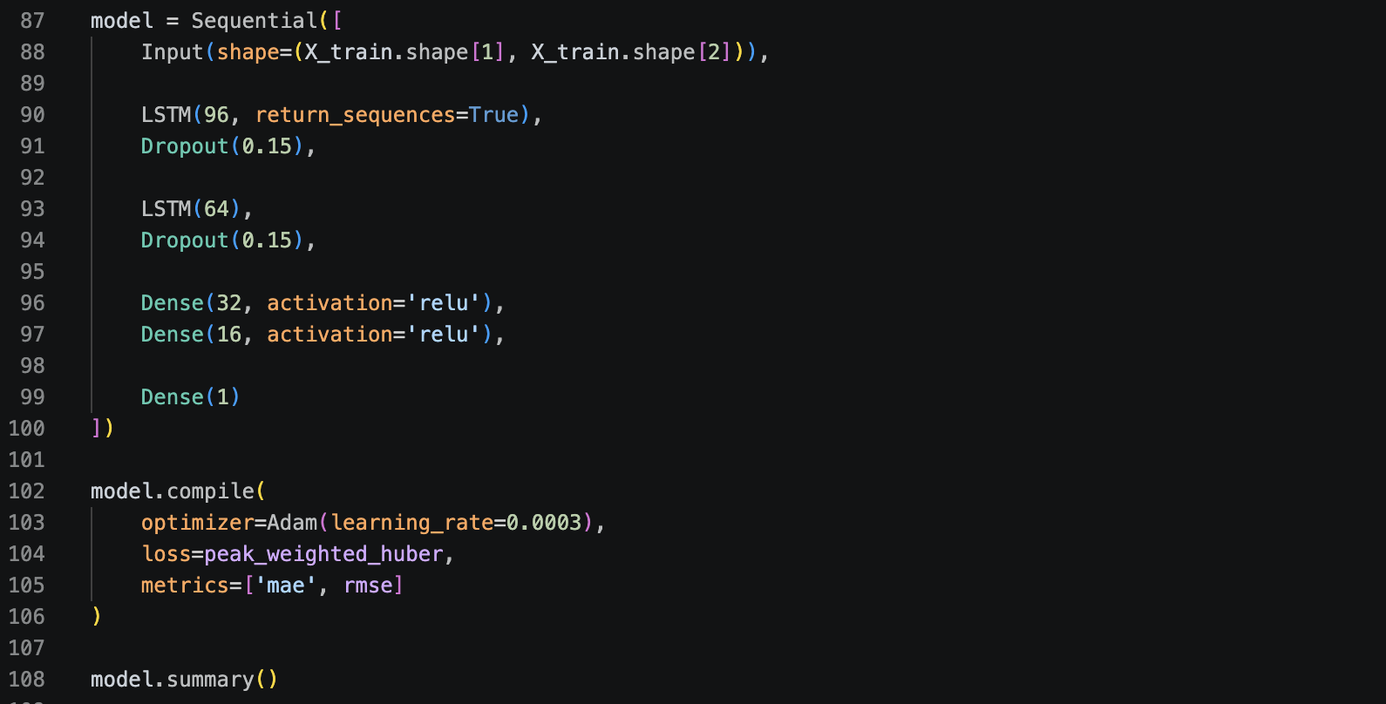
Methodology: Sequence Length Experiments
To evaluate the impact of temporal context, a series of LSTM models were trained using different sequence lengths: 1, 2, 4, 6, 8, 10, and 12 weeks.
For each configuration:
- The model architecture was kept identical (same LSTM structure and hyperparameters)
- Only the input sequence length was modified
- Data splitting and preprocessing were kept consistent
- Training was performed under the same optimization settings
Purpose: isolate effect of temporal window size

Sequence Length Comparison Results

Sequence (weeks) | MAE (mean) | MAE (std) | RMSE (mean) | RMSE (std)
1 | 0.530 | 0.011 | 0.811 | 0.010
2 | 0.514 | 0.014 | 0.813 | 0.014
4 | 0.454 | 0.018 | 0.715 | 0.018
6 | 0.380 | 0.012 | 0.616 | 0.015
8 | 0.438 | 0.046 | 0.673 | 0.047
10 | 0.452 | 0.046 | 0.687 | 0.048
12 | 0.474 | 0.057 | 0.702 | 0.058
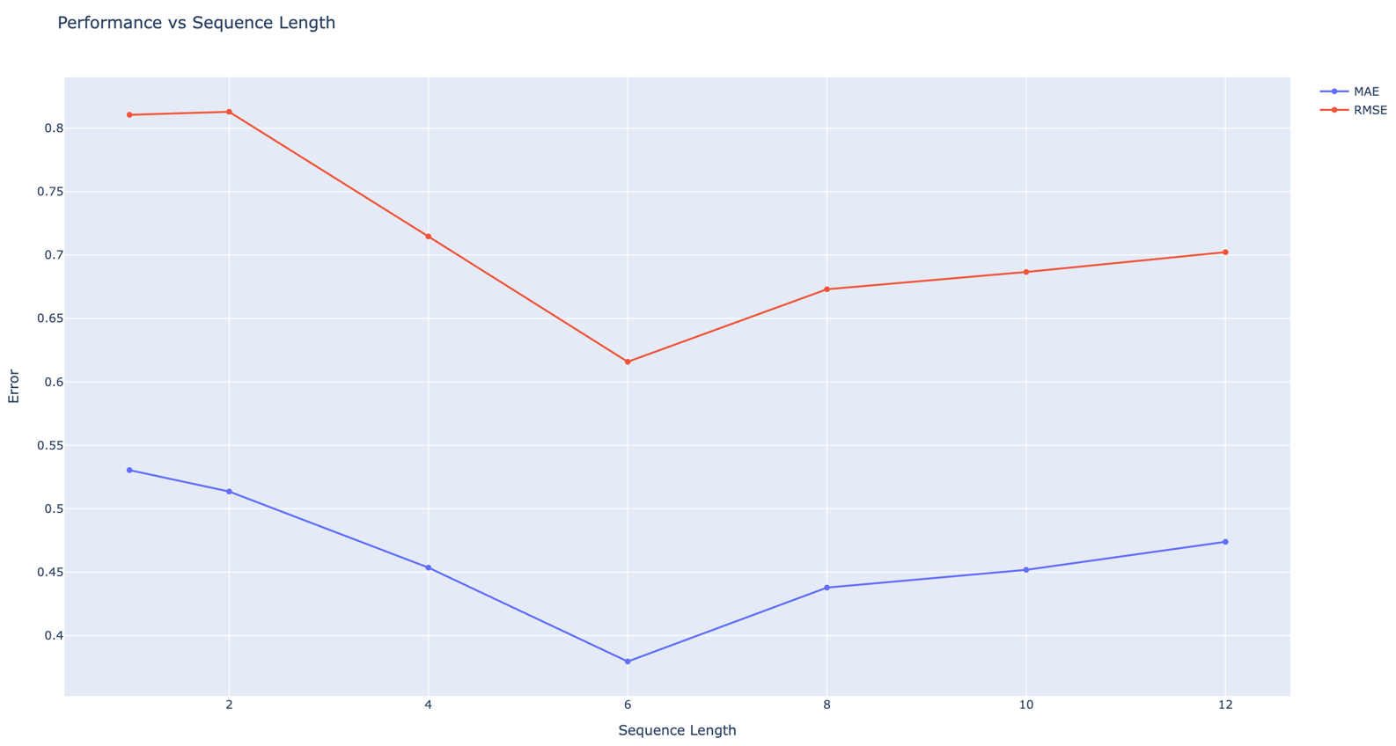

Effect of Sequence Length
- Short sequences (1–2 weeks) show higher error (MAE/RMSE), indicating insufficient temporal context for learning meaningful patterns.
- Medium sequences (4–6 weeks) significantly improve performance, suggesting that the model benefits from a moderate historical window.
- Longer sequences (8–12 weeks) do not consistently improve results and sometimes degrade performance, likely due to:
- increased noise accumulation,
- redundant temporal information,
- higher learning complexity.

Best Performing Configuration

• The 6-week sequence length achieved the best overall trade-off:
- Lowest MAE: 0.380
- Lowest RMSE: 0.616

6-week sequence: best numerical performance
8-week sequence: better visual stability and peak realism

There is no single dominant configuration; instead, a trade-off exists between numerical accuracy and temporal realism.

Stability vs Performance Trade-off

- Although 6 weeks gives the best mean performance, it is not always the most visually stable model across runs.
- Some variability appears in longer sequences (higher std values), indicating:
- sensitivity to training initialization
- possible overfitting to longer temporal dependencies.

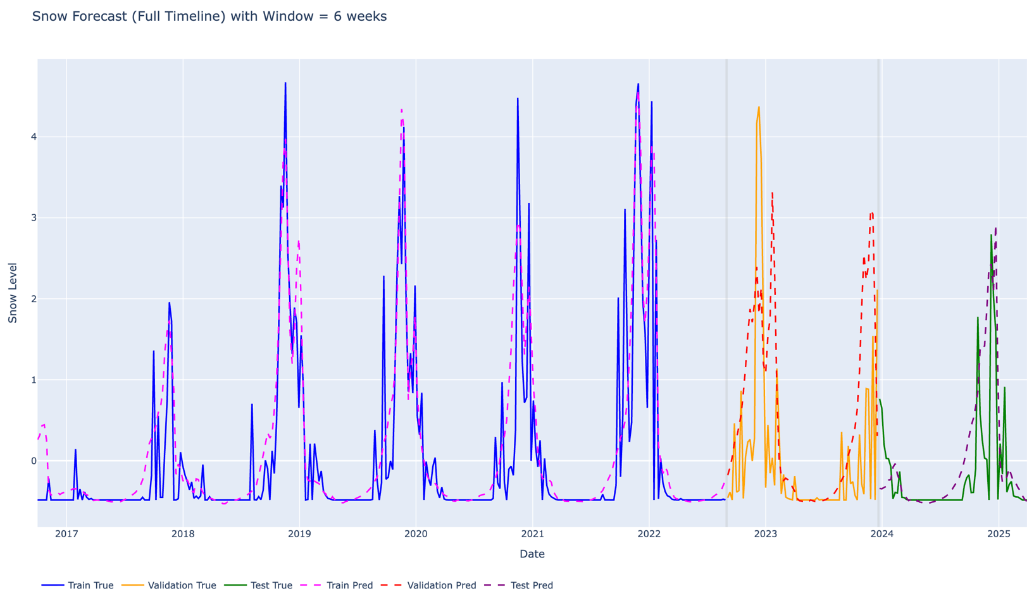

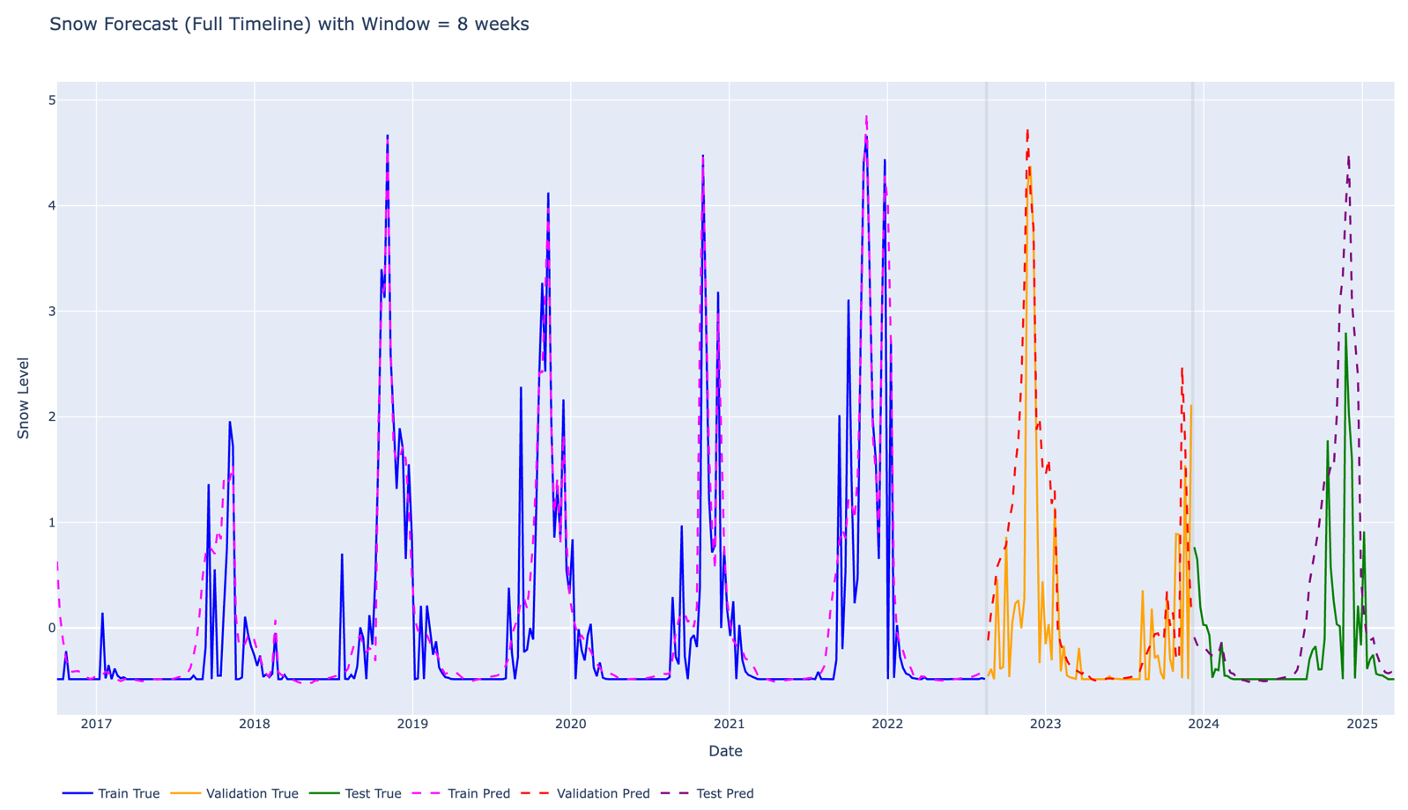

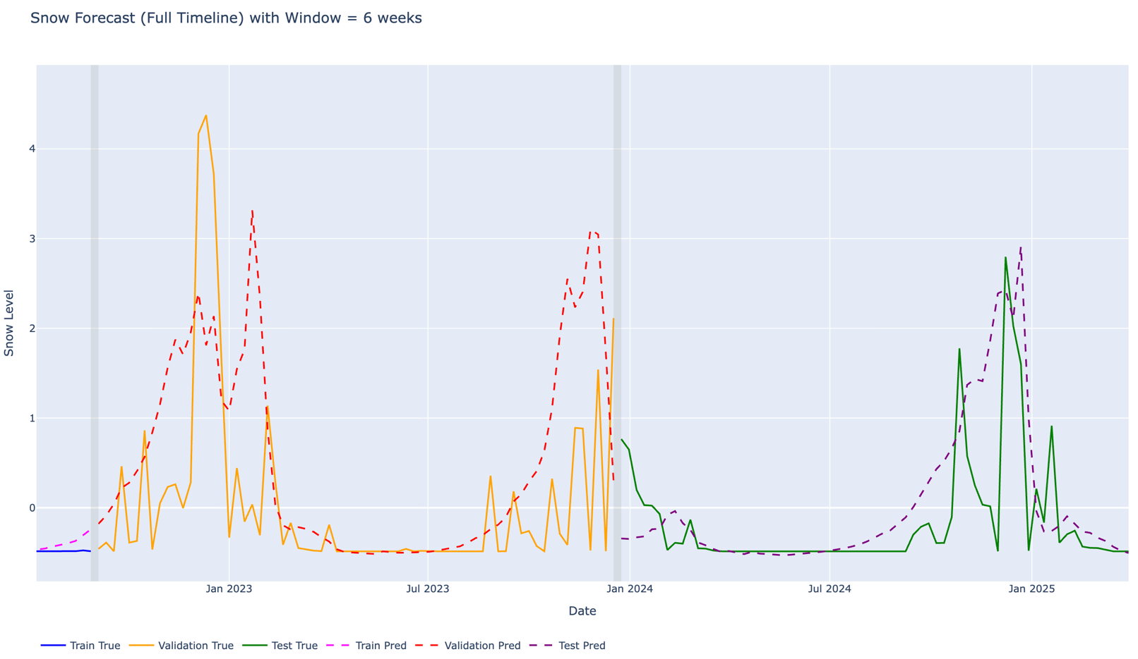

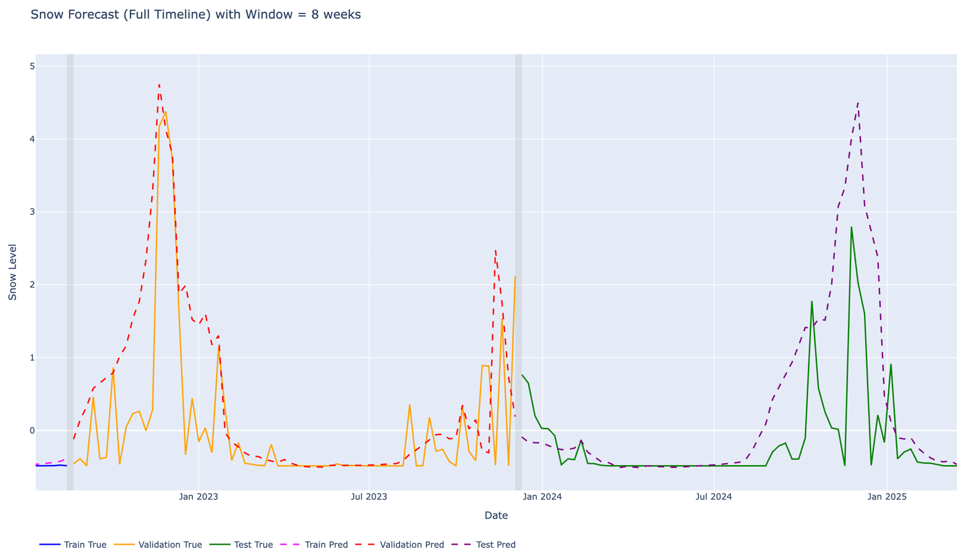

Visual vs Numerical Consistency

• Visual inspection of prediction plots showed that:
- Some sequence lengths produce smoother curves (better visual realism)
- while others achieve lower RMSE but less visually meaningful peaks.

• This highlights an important trade-off between:
- numerical accuracy (MAE/RMSE)
- forecast interpretability (peak behavior and realism)

MODIS 25-Year Benchmark Experiment
To investigate whether the limitations observed in the Sentinel-2 models were related to the dataset size or inherent data characteristics, an additional experiment was conducted using a long-term MODIS dataset spanning 25 years of observations.
The same LSTM architecture and training procedure were applied to ensure a fair comparison with the Sentinel-2 experiments.
Results showed improved visual stability and closer alignment with real trends, although RMSE remained around ~0.6. In the context of snow variability in mountainous regions such as Lebanon, this level of error is expected and reflects natural environmental complexity rather than model failure.
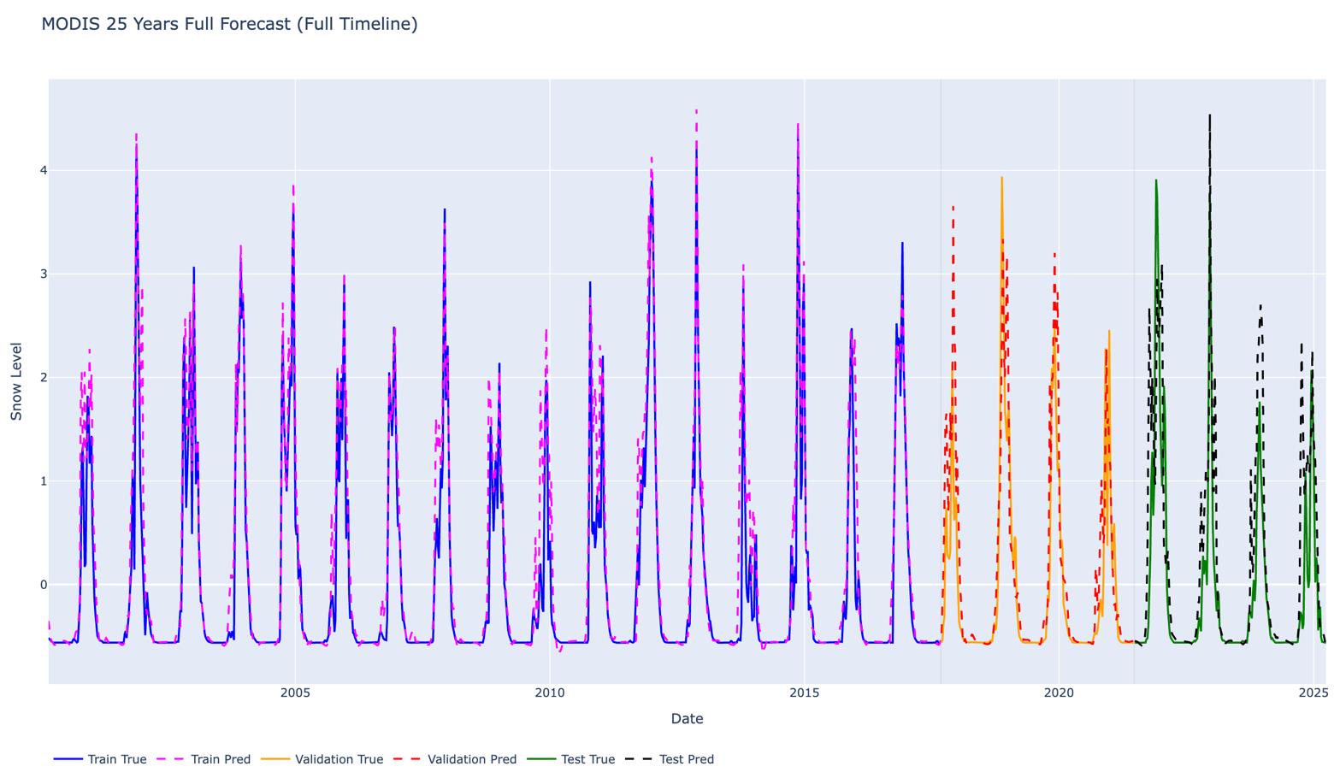

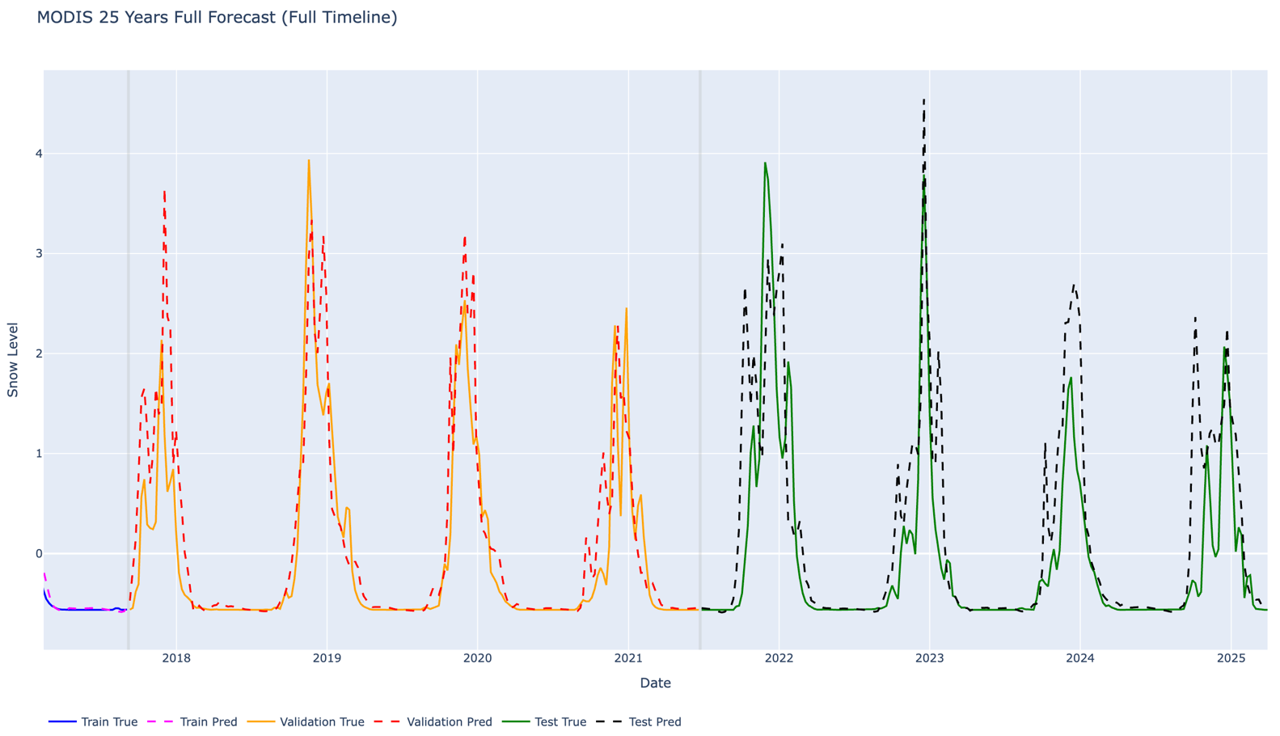

Conclusion
This study evaluated the impact of different sequence lengths on LSTM-based snow forecasting using Sentinel-2 data. Results showed that no single configuration is strictly optimal across all criteria: while the 6-week model generally achieved slightly better numerical performance (lower MAE/RMSE in some runs), the 8-week model produced more stable and visually realistic predictions, particularly in capturing snow variability and peak behavior.
To further investigate data limitations, a supplementary experiment using a long-term MODIS dataset (25 years) was conducted. Results indicated improved stability and smoother prediction alignment with observed trends, suggesting that data availability and temporal coverage significantly influence model performance. However, even with extended data, prediction error remained due to the inherently high variability of snow dynamics in mountainous regions.

